Millennium Database Monitoring Overview
Our database monitoring is best of breed and developed by Ed. My tools are the product of 20+ years of constant development of systems administration tools for Sybase and Sql Server. This has resulted in a set of tools designed specifically to solve database systems administration problems and, in my opinion, both the tools and the results are superior to those produced by commercial products like Patrol and Idera. The key is a considerable knowledge base of what works and what does not works. I have basically written a program to check for every issue I have encountered in my entire career as a dba. I have a philosophy that mistakes only happen once, and that tools should prevent preventable mistakes.
The language I use is Perl. A central database exists as a repository of all information. My primary user interface is email and html. The code line exists on a samba share so that it runs transparently on UNIX and windows. The same code monitors Sybase and Sql Server. The primary monitor stations are sybmon (Linux, monitors all UNIX dbms systems) and adsvm092, (win32, monitors all windows dbms systems). A Sybase database stores all the information and lives on host sybmon.
I am currently migrating to a new ‘cleaner’ environment on adsrv115/ctsybmon.
On Linux, the jobs are scheduled using cron on sybase@sybmon. Windows jobs are scheduled using the scheduled tasks on adsvm092. Linux monitoring relies on native/no password ssh connectivity to target hosts and Windows monitoring relies on native ‘administrator’ rights to extract information using the windows native call interface. Dbms monitoring on UNIX relies on login/passwords, while native authentication is used for windows databases.

Oracle and Mysql support is not ‘best of breed’ but seem adequate when combined with the vendor tools.

In a nutshell, the system is built on configuration files – including password files for each type of system (Sybase, Oracle, Mysql, Sql Server, Win32, and UNIX). Batch jobs are dynamically built scheduled based on these files. Everything else flows automatically. In order to add monitoring to a new Sql server, we add it to the windows and Sql server password files and we are done.

Component Systems

Stored Procedure Library – Freeware (?1991?-2011) was a rewrite of the sybase internal stored procedures which have many problems and often do not do a good job displaying needed information. These are widely used within millennium and I estimate are in use at 1000+ companies worldwide.

Backup Scripts - Widely used freeware to backup sybase & sql server. We use native sql server backup plans on 2005/2008 (its graphical and works well).

Credentials – All system and database credentials are collected and can be viewed centrally. Main business systems have the list of users who have access audited by the business quarterly (SAS 70 Requirement).
- LDAP User
- Data bases Logins & User System Tables
- Unix /etc/passwd
- NIS

Monitoring – Alerts and Heartbeats are collected centrally and mail are sent to administrators when problems arise. (details later)

Configuration Audits – security & configuration checks.
- sp__auditdb
- sp__auditsecurity
- Currently v2 under development – policy based

End User Reporting & Performance– (new) – pre-generated static reports or dynamic performance reports.
- Queries Run On Each Server
- SystemInfo (windows command)
- Dr_Checker.pl

BackupState
- Commands in my batch backup scripts
- Batch Jobs to Collect Data
- Scrubbing Backup Logs
- Looking At File Systems

Inventory System
- Under Development (may be replaced by remedy)
- WASP, DCM, LDAP, Unix Inventory, Tape Backup System
- Dbms AutoDiscovery / Surveys
Monitoring
- Error/Event Logs
  - Sybase ASE
    - Database logs
    - Backup logs (did backups occur)
  - Oracle (weak – their log format sucks)
  - Windows Event log
  - Microsoft SQL Server
    - Database logs
    - Backup logs (did backups occur)
  - Windows Scheduler
  - Microsoft SQL Server Job Scheduler
  - Sybase Replication (latency, is it working)
  - Sql Server Replication (customized)
  - Unix Messages (from monitor – currently off)
- Availability
  - Windows Services
  - Port Monitoring (i.e. host/portnum pairs)
  - System Availability (ping)
  - Mysql servers
- Space
  - Disk Space (unix via df and windows using wmi)
  - Database Space on Sybase (on windows we only need to monitor disk space)
  - Space History is Tracked For Databases
- Database Checker / Internals Monitoring
  - Blocks
  - Bad Process State
  - Circular Deadlocks
  - Users and Load (long running io/cpu…)
  - Invalid Users & Objects
  - Large Transaction Logs
- Threshold based Sybase Checks
  - Checks when database data or log > percentage of available space
- File / Directory size checker and purger
  - Configurable by –versions or –date
  - unix and windows
  - Purges in a configurable decent way
  - Can check that recent version of a file (excluding timestamp) is in a directory
- Miscellaneous
  - Traceroute (delays & num hops)
  - Batch Auto truncation of system db’s
  - Batch Auto shrink of user db’s
  - Checks dns server availability / functionality
Database Auditing
- Tracks all db configuration changes
- Security/Configuration Rules Base
  - sp__auditsecurity
  - sp__auditdb
- Results mapped to policies
- Dr Checker
Alarming
- Configurable Operator Scheduler
- Blackout Periods
- Flexible Alarm Filtering
- Viewable on web
- Perl Function API
End User Reporting & Performance
- Based on flat files stored in …/ADMIN_SCRIPTS/database_queries
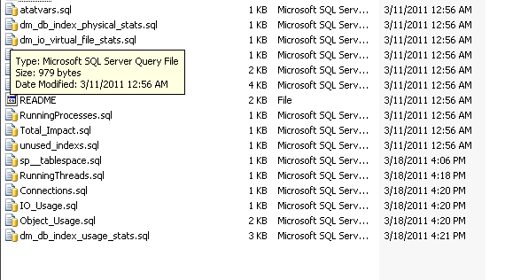
- File Layout
-- report_key=DM_EXEC_QUERY_STATS key
-- run_frequency=Daily|Weekly|Hourly|15min|5min
-- do_diff=Y diff output from last
-- keep_hours=N keep hourly data
-- keep_6=N keep 6 minute data
-- server_type=sqlsvr|oracle|mysql|sybase type of svr to run on
-- exclude_server_csv= csv list of servers
-- run_on_server_csv= csv list of servers
-- server_min_version= version filter min
-- server_max_version= version filter max
-- run_query_each_db=Y|N run once or in each db
-- run_query_in_sys_db=Y|N run in master/model…
-- report_header= html at start of report
-- report_footer= html at end of report
-- enabled=y|n will run only if y
-- performancetype=int only int for now
-- performancekey=DM_EXEC_QUERY_STATS performance report key
-- colname_csv=X,X,1,2,3 column list for query
-- debug=1 if set – diagnostic mode

< QUERY GOES HERE >

Batch Jobs
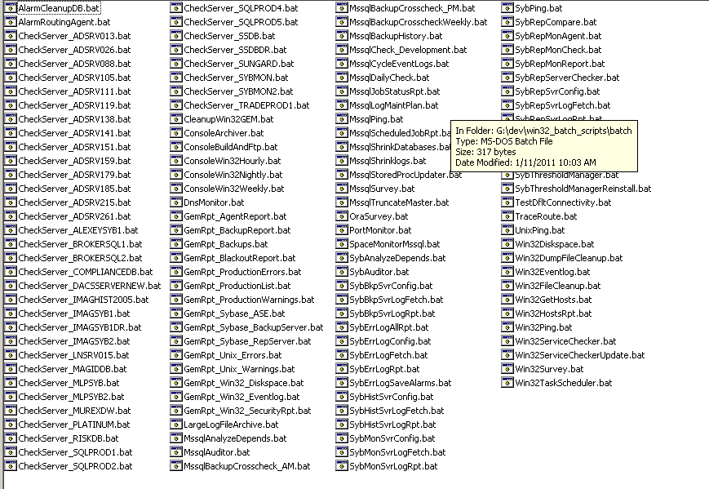
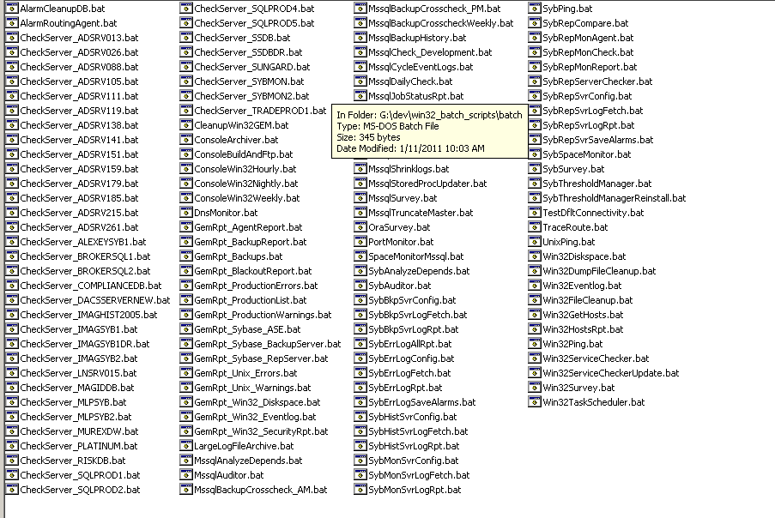
Enterprise Dashboard (dba view)

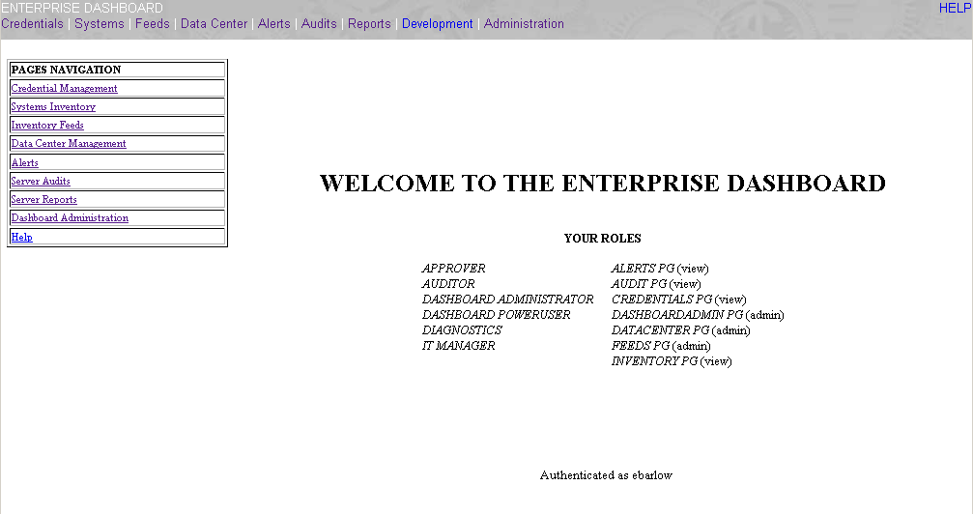

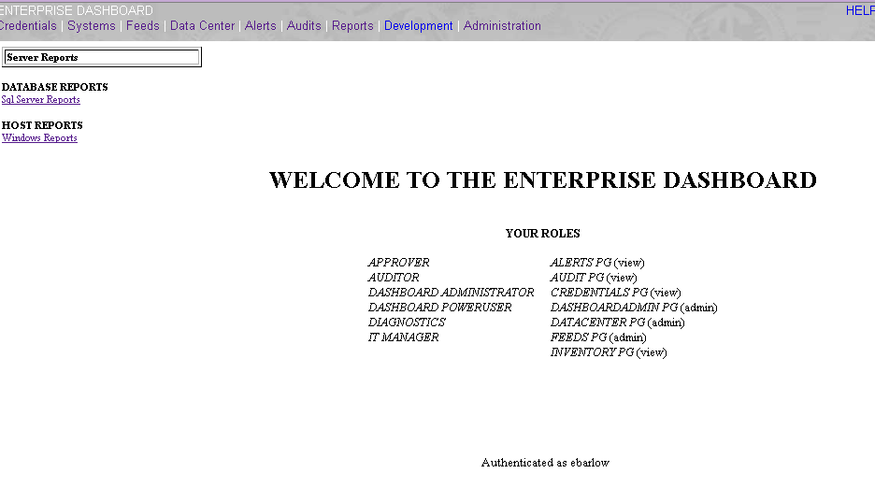
Server Reports

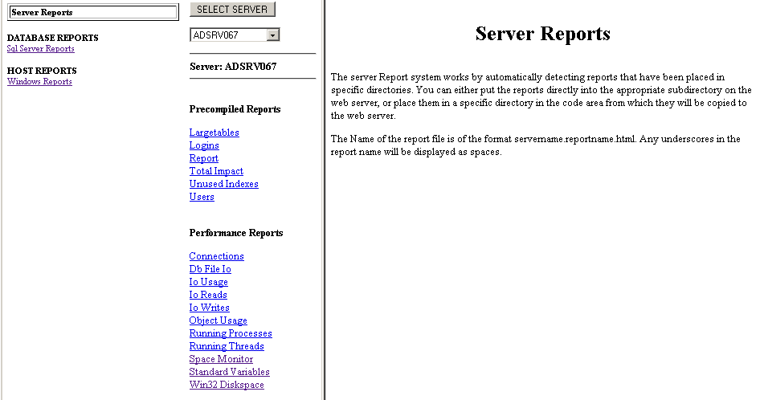

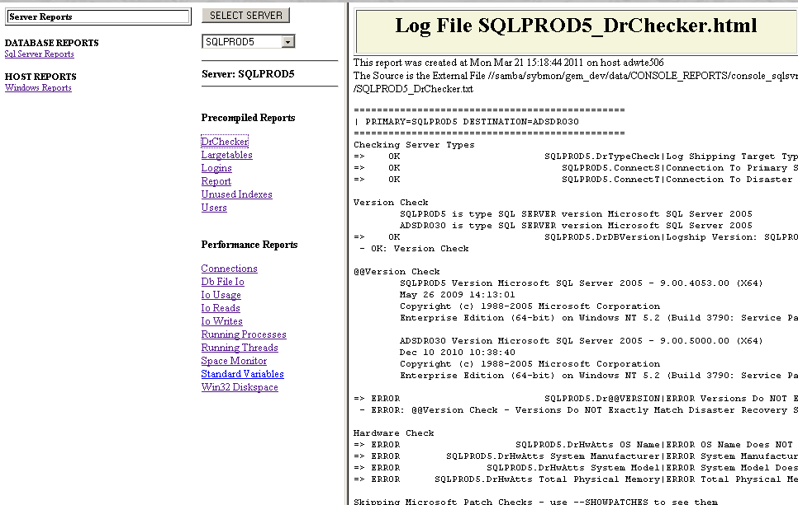

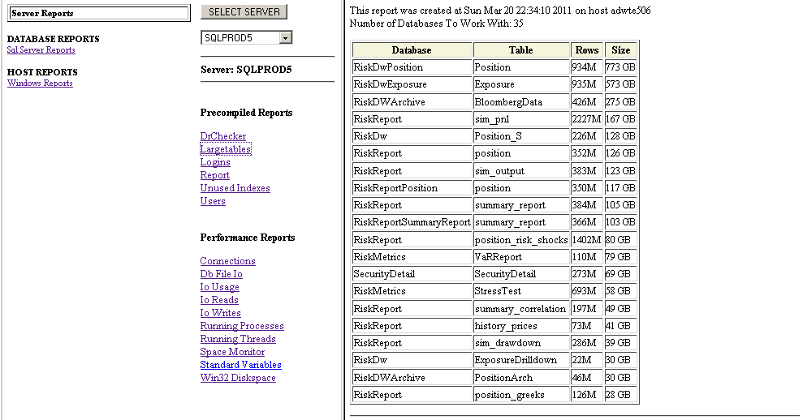

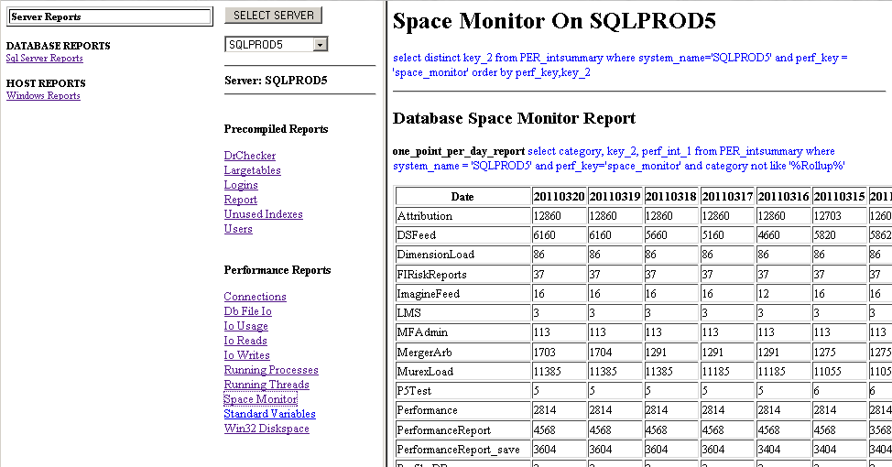
Windows Reports

